Day in the Life of the Hudson River 10/14/21
RENSSELAER BOAT LAUNCH
RIVER MILE: 146
Salt Front: ~ RM 49
Tech Valley High School- Diana Weldon, Tim Muzio and 3 other teachers
68 students, 9th grade biology, 12th grade statistics
Latitude 42.6587 N & Longitude – 73.73452 W
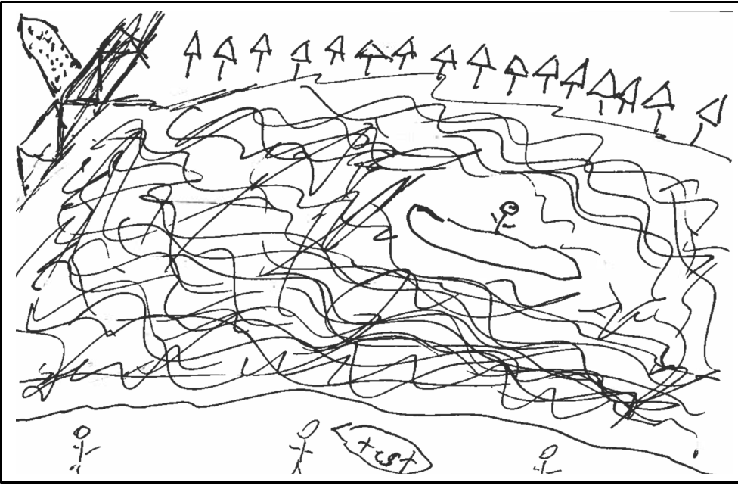
Location: Rensselaer Boat Launch, Rensselaer County, NY
Area: Concrete boat launch with small beach area, removable dock, wooded, landscaped, adjacent to urban, residential, and industrial areas.
Surrounding Land Use: 30% Urban/Residential, 30% Industrial/Commercial, 15% Park, 15% Beach, 10% Forested
Sampling Site: Beach, forested
Shoreline: Sandy
Water: calm
River Bottom: muddy

ITEM | Time | Reading |  |  |  | Comments
Physical
Air Temperature | 9:00 AM  9:00 AM  9:30 AM  10:30 AM  12:00 PM  12:00 PM  12:15 PM  1:00 PM | 17.8 º C  18.6 º C  18.2 º C  22 º C  20 º C  21 º C  22 º C  24 º C |  |  | 64 º F  65.5 º F  65 º F  71.6 º F  68 º F  70 º F  72 º F  75 º F
Wind Speed: | NR
Weather today | 10:00 AM- partly-cloudy (26-50%)
Weather the past 3 days: | NR
Tides- | Time | Rising, Falling, Unchanged |  |  | Height (cm)
 | NR
Current- | Time | Cm/sec | Knots |  | North/South | Ebb/Flood/Still
 | NR
Water Temperature- Water depth <1 ft | 9:30 AM  12:30 PM | 17, 19, Avg: 17.6º C  19, 20, Avg: 19.4 ºC |  |  | 62.6, 66.2, Avg: 63.7 ºF  66.2, 68, Avg: 67 º F
Turbidity- Long sight tube | 9:30 AM  12:30 PM | 15 cm, 20 cm, 10 cm  10 cm, 5 cm |  |  |  | *highly turbid readings
Chemical
Salinity- used LaMotte salinity titration - test kit (7459-02) | 9:30 AM  12:30 PM | 1000 ppm, 500 pp, 500 ppm, 500 ppm, 750 ppm, 250 ppm |  | These readings are very high. Possibly due to kit used. Would not expect these levels even if they were measuring salt from soil or groundwater leaching
DO – Chemets | Time | Temp |  |  | ppm DO | % saturation
 | 9:30 AM  9:30 AM  12:30 PM  12:30 PM  12:30 PM | 20 ºC  13 ºC  18 ºC  20 ºC  21 ºC |  |  | 9 ppm  10 ppm  12ppm  10 ppm  9 ppm | 98%  95%  125%  108%  100%
pH – test strips | 9:30 AM  12:30 PM | 6, 6.4, 6.8  6.4, 6.4, 6.4
Alkalinity- LaMotte Titration | 9:30 AM  12:30 PM | 60 ppm, 90 ppm, 70 ppm  40 ppm, 60 ppm, 90 ppm
Nitrate- used two different methods | 9:30 AM  12:30 PM | LaMotte: 2 ppm, 1 ppm  LaMotte: 1 ppm, 0 ppm, 2 ppm |  |  |  | Chemets: 0 ppm  Chemets: 0 ppm
Phosphate- Chemets | 9:30 AM  12:30 PM | <1 ppm  <1 ppm, 1 ppm
Biological
Fish- Did not fish | Number | Name |  |  | Length of longest | Length of smallest
Fish Totals | TOTAL: | Diversity:

